**Lucrare de laborator Nr.5 (VariantaVII)**

Creaţi o pagină web, care va afişa următoarea imagine. Fiecare din cele trei „săltare” din imagine va fi o legătură către un fişier html care va conţine informaţii despre ziarele, sau revistele, sau canalele TV din tară.

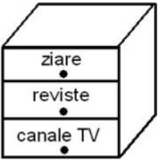

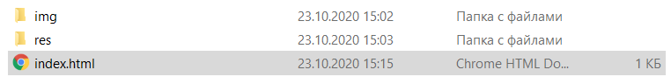

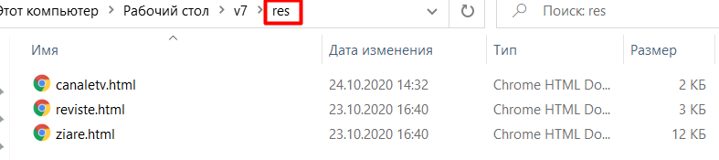

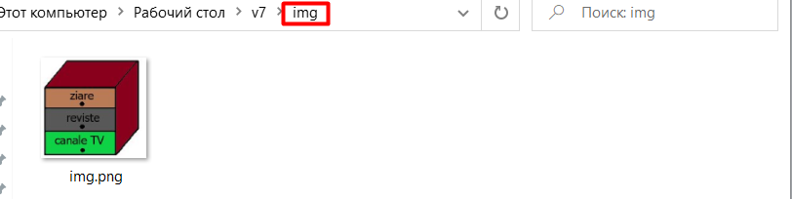

„Index.html” conține codul:

<!DOCTYPE html>

<html>

<head >

<title>Lucru independent</title>

</head ><body align=center>

<img src="img/img.png" usemap="#s">

<Map name="s">

<Area shape = rect coords="8,48,121,81" href="res/ziare.html" target="_blank">

<Area shape = rect coords="8,83,122,119" href="res/reviste.html" target="_blank">

<Area shape = rect coords="8,121,120,157" href="res/canaletv.html" target="_blank">

</Map>

</body>

<html>

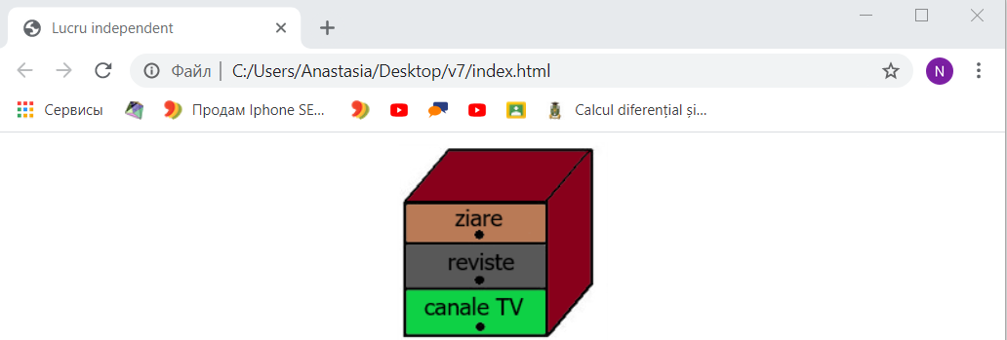

**Accesând saltarul “Ziare” vedem următoarea pagină:**

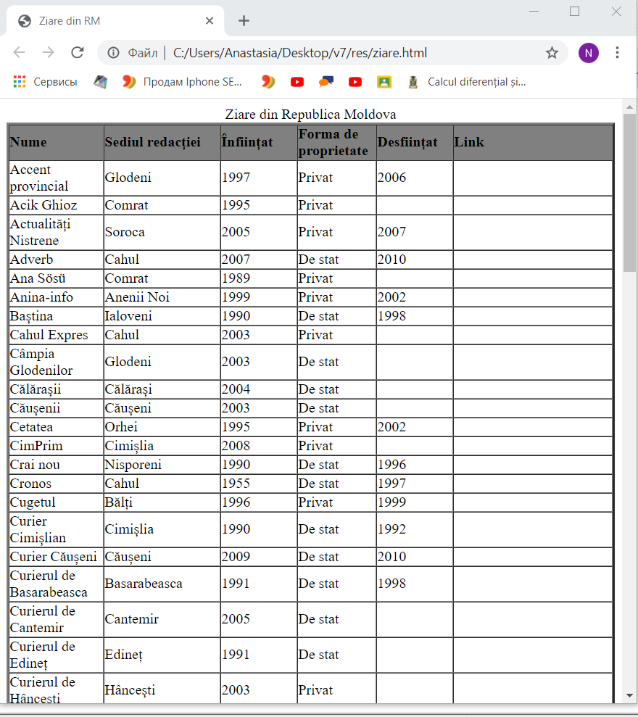

**Codul acestei pagini este:**

**<!DOCTYPE html>**

**<html>**

**<head >**

**<title>Ziare din RM</title>**

**</head >**

**<body>**

**<table border="3" cellpadding="0" cellspacing="0" >**

**<caption >Ziare din Republica Moldova**

**</caption>**

**<thead bgcolor="gray"><tr>**

**<th width="75" align="left">Nume**

**</th>**

**<th width="115" align="left">Sediul redacției**

**</th>**

**<th width="75" align="left">Înființat**

**</th>**

**<th width="60" align="left">Forma de proprietate**

**</th>**

**<th width="75" align="left">Desființat**

**</th>**

**<th width="75" align="left">Link**

**</th></tr></thead><tbody>**

**<tr>**

**<td>Accent provincial**

**</td>**

**<td>Glodeni**

**</td>**

**<td>1997**

**</td>**

**<td>Privat**

**</td>**

**<td>2006**

**</td>**

**<td>**

**</td></tr>**

**<tr>**

**<td>Acik Ghioz**

**</td>**

**<td>Comrat**

**</td>**

**<td>1995**

**</td>**

**<td>Privat**

**</td>**

**<td>**

**</td>**

**<td>**

**</td></tr>**

**<tr>**

**<td>Actualități Nistrene**

**</td>**

**<td>Soroca**

**</td>**

**<td>2005**

**</td>**

**<td>Privat**

**</td>**

**<td>2007**

**</td>**

**<td>**

**</td></tr>**

**<tr>**

**<td>Adverb**

**</td>**

**<td>Cahul**

**</td>**

**<td>2007**

**</td>**

**<td>De stat**

**</td>**

**<td>2010**

**</td>**

**<td>**

**</td></tr>**

**<tr>**

**<td>Ana Sösü**

**</td>**

**<td>Comrat**

**</td>**

**<td>1989**

**</td>**

**<td>Privat**

**</td>**

**<td>**

**</td>**

**<td>**

**</td></tr>**

**<tr>**

**<td>Anina-info**

**</td>**

**<td>Anenii Noi**

**</td>**

**<td>1999**

**</td>**

**<td>Privat**

**</td>**

**<td>2002**

**</td>**

**<td>**

**</td></tr>**

**<tr>**

**<td>Baștina**

**</td>**

**<td>Ialoveni**

**</td>**

**<td>1990**

**</td>**

**<td>De stat**

**</td>**

**<td>1998**

**</td>**

**<td>**

**</td></tr>**

**<tr>**

**<td>Cahul Expres**

**</td>**

**<td>Cahul**

**</td>**

**<td>2003**

**</td>**

**<td>Privat**

**</td>**

**<td>**

**</td>**

**<td>**

**</td></tr>**

**<tr>**

**<td>Câmpia Glodenilor**

**</td>**

**<td>Glodeni**

**</td>**

**<td>2003**

**</td>**

**<td>De stat**

**</td>**

**<td>**

**</td>**

**<td>**

**</td></tr>**

**<tr>**

**<td>Călărașii**

**</td>**

**<td>Călărași**

**</td>**

**<td>2004**

**</td>**

**<td>De stat**

**</td>**

**<td>**

**</td>**

**<td>**

**</td></tr>**

**<tr>**

**<td>Căușenii**

**</td>**

**<td>Căușeni**

**</td>**

**<td>2003**

**</td>**

**<td>De stat**

**</td>**

**<td>**

**</td>**

**<td>**

**</td></tr>**

**<tr>**

**<td>Cetatea**

**</td>**

**<td>Orhei**

**</td>**

**<td>1995**

**</td>**

**<td>Privat**

**</td>**

**<td>2002**

**</td>**

**<td>**

**</td></tr>**

**<tr>**

**<td>CimPrim**

**</td>**

**<td>Cimișlia**

**</td>**

**<td>2008**

**</td>**

**<td>Privat**

**</td>**

**<td>**

**</td>**

**<td>**

**</td></tr>**

**<tr>**

**<td>Crai nou**

**</td>**

**<td>Nisporeni**

**</td>**

**<td>1990**

**</td>**

**<td>De stat**

**</td>**

**<td>1996**

**</td>**

**<td>**

**</td></tr>**

**<tr>**

**<td>Cronos**

**</td>**

**<td>Cahul**

**</td>**

**<td>1955**

**</td>**

**<td>De stat**

**</td>**

**<td>1997**

**</td>**

**<td>**

**</td></tr>**

**<tr>**

**<td>Cugetul**

**</td>**

**<td>Bălți**

**</td>**

**<td>1996**

**</td>**

**<td>Privat**

**</td>**

**<td>1999**

**</td>**

**<td>**

**</td></tr>**

**<tr>**

**<td>Curier Cimișlian**

**</td>**

**<td>Cimișlia**

**</td>**

**<td>1990**

**</td>**

**<td>De stat**

**</td>**

**<td>1992**

**</td>**

**<td>**

**</td></tr>**

**<tr>**

**<td>Curier Căușeni**

**</td>**

**<td>Căușeni**

**</td>**

**<td>2009**

**</td>**

**<td>De stat**

**</td>**

**<td>2010**

**</td>**

**<td>**

**</td></tr>**

**<tr>**

**<td>Curierul de Basarabeasca**

**</td>**

**<td>Basarabeasca**

**</td>**

**<td>1991**

**</td>**

**<td>De stat**

**</td>**

**<td>1998**

**</td>**

**<td>**

**</td></tr>**

**<tr>**

**<td>Curierul de Cantemir**

**</td>**

**<td>Cantemir**

**</td>**

**<td>2005**

**</td>**

**<td>De stat**

**</td>**

**<td>**

**</td>**

**<td>**

**</td></tr>**

**<tr>**

**<td>Curierul de Edineț**

**</td>**

**<td>Edineț**

**</td>**

**<td>1991**

**</td>**

**<td>De stat**

**</td>**

**<td>**

**</td>**

**<td>**

**</td></tr>**

**<tr>**

**<td>Curierul de Hâncești**

**</td>**

**<td>Hâncești**

**</td>**

**<td>2003**

**</td>**

**<td>Privat**

**</td>**

**<td>**

**</td>**

**<td>**

**</td></tr>**

**<tr>**

**<td>Curierul de Leova**

**</td>**

**<td>Leova**

**</td>**

**<td>2004**

**</td>**

**<td>De stat**

**</td>**

**<td>**

**</td>**

**<td>**

**</td></tr>**

**<tr>**

**<td>Cuvântul**

**</td>**

**<td>Rezina**

**</td>**

**<td>1995**

**</td>**

**<td>Privat**

**</td>**

**<td>**

**</td>**

**<td><a href="http://www.cuvintul.md/">http://www.cuvintul.md/</a>**

**</td></tr>**

**<tr>**

**<td>Cuvântul liber**

**</td>**

**<td>Leova**

**</td>**

**<td>1997**

**</td>**

**<td>Privat**

**</td>**

**<td>**

**</td>**

**<td>**

**</td></tr>**

**<tr>**

**<td>Cuvântul Liber ST**

**</td>**

**<td>Strășeni**

**</td>**

**<td>1950**

**</td>**

**<td>De stat**

**</td>**

**<td>**

**</td>**

**<td>**

**</td></tr>**

**<tr>**

**<td>Deșteptarea**

**</td>**

**<td>Nisporeni**

**</td>**

**<td>2004**

**</td>**

**<td>Privat**

**</td>**

**<td>**

**</td>**

**<td>**

**</td></tr>**

**<tr>**

**<td>Drapelul**

**</td>**

**<td>Florești**

**</td>**

**<td>2003**

**</td>**

**<td>De stat**

**</td>**

**<td>**

**</td>**

**<td>**

**</td></tr>**

**<tr>**

**<td>Drapelul Muncii**

**</td>**

**<td>Anenii Noi**

**</td>**

**<td>2003**

**</td>**

**<td>De stat**

**</td>**

**<td>**

**</td>**

**<td>**

**</td></tr>**

**<tr>**

**<td>Duminica**

**</td>**

**<td>Fălești**

**</td>**

**<td>1997**

**</td>**

**<td>Privat**

**</td>**

**<td>2000**

**</td>**

**<td>**

**</td></tr>**

**<tr>**

**<td>Ecoul**

**</td>**

**<td>Sângerei**

**</td>**

**<td>1990**

**</td>**

**<td>De stat**

**</td>**

**<td>1999**

**</td>**

**<td>**

**</td></tr>**

**<tr>**

**<td>Ecoul nostru**

**</td>**

**<td>Sângerei**

**</td>**

**<td>1999**

**</td>**

**<td>Privat**

**</td>**

**<td>**

**</td>**

**<td>**

**</td></tr>**

**<tr>**

**<td>Eni Gagauzia**

**</td>**

**<td>Comrat**

**</td>**

**<td>2010**

**</td>**

**<td>Privat**

**</td>**

**<td>**

**</td>**

**<td>**

**</td></tr>**

**<tr>**

**<td>Est-Curier**

**</td>**

**<td>Criuleni**

**</td>**

**<td>1997**

**</td>**

**<td>Privat**

**</td>**

**<td>**

**</td>**

**<td>**

**</td></tr>**

**<tr>**

**<td>Eveniment actual**

**</td>**

**<td>Râșcani**

**</td>**

**<td>2004**

**</td>**

**<td>De stat**

**</td>**

**<td>**

**</td>**

**<td>**

**</td></tr>**

**<tr>**

**<td>Expresul de Ungheni**

**</td>**

**<td>Ungheni**

**</td>**

**<td>2007**

**</td>**

**<td>Privat**

**</td>**

**<td>**

**</td>**

**<td>**

**</td></tr>**

**<tr>**

**<td>Farul Nistrean**

**</td>**

**<td>Rezina**

**</td>**

**<td>1948**

**</td>**

**<td>De stat**

**</td>**

**<td>**

**</td>**

**<td>**

**</td></tr>**

**<tr>**

**<td>Flux de Bălți**

**</td>**

**<td>Bălți**

**</td>**

**<td>1999**

**</td>**

**<td>Privat**

**</td>**

**<td>1999**

**</td>**

**<td>**

**</td></tr>**

**<tr>**

**<td>Flux de Orhei**

**</td>**

**<td>Orhei**

**</td>**

**<td>1999**

**</td>**

**<td>Privat**

**</td>**

**<td>1999**

**</td>**

**<td>**

**</td></tr>**

**<tr>**

**<td>Flux de Ungheni**

**</td>**

**<td>Ungheni**

**</td>**

**<td>1999**

**</td>**

**<td>Privat**

**</td>**

**<td>1999**

**</td>**

**<td>**

**</td></tr>**

**<tr>**

**<td>Gagauz halki**

**</td>**

**<td>Comrat**

**</td>**

**<td>1999**

**</td>**

**<td>Privat**

**</td>**

**<td>2004**

**</td>**

**<td>**

**</td></tr>**

**<tr>**

**<td>Gagauzlar**

**</td>**

**<td>Comrat**

**</td>**

**<td>2009**

**</td>**

**<td>Privat**

**</td>**

**<td>**

**</td>**

**<td>**

**</td></tr>**

**<tr>**

**<td>Gazeta de Sud**

**</td>**

**<td>Cimișlia**

**</td>**

**<td>1995**

**</td>**

**<td>Privat**

**</td>**

**<td>**

**</td>**

**<td>**

**</td></tr>**

**<tr>**

**<td>Gazeta de Vest**

**</td>**

**<td>Nisporeni**

**</td>**

**<td>1996**

**</td>**

**<td>Privat**

**</td>**

**<td>**

**</td>**

**<td>**

**</td></tr>**

**<tr>**

**<td>Gazeta.MD**

**</td>**

**<td>Bălți**

**</td>**

**<td>2007**

**</td>**

**<td>Privat**

**</td>**

**<td>**

**</td>**

**<td>**

**</td></tr>**

**<tr>**

**<td>Glia Drochiană**

**</td>**

**<td>Drochia**

**</td>**

**<td>1999**

**</td>**

**<td>Privat**

**</td>**

**<td>**

**</td>**

**<td>**

**</td></tr>**

**<tr>**

**<td>La strajă**

**</td>**

**<td>Leova**

**</td>**

**<td>1948**

**</td>**

**<td>De stat**

**</td>**

**<td>1998**

**</td>**

**<td>**

**</td></tr>**

**<tr>**

**<td>Luceafărul**

**</td>**

**<td>Hâncești**

**</td>**

**<td>1948**

**</td>**

**<td>De stat**

**</td>**

**<td>1999**

**</td>**

**<td>**

**</td></tr>**

**<tr>**

**<td>Lunca Prutului**

**</td>**

**<td>Glodeni**

**</td>**

**<td>1991**

**</td>**

**<td>De stat**

**</td>**

**<td>1999**

**</td>**

**<td>**

**</td></tr>**

**<tr>**

**<td>Meleag natal**

**</td>**

**<td>Briceni**

**</td>**

**<td>1965**

**</td>**

**<td>De stat**

**</td>**

**<td>**

**</td>**

**<td>**

**</td></tr>**

**<tr>**

**<td>Meridian Ocnița**

**</td>**

**<td>Ocnița**

**</td>**

**<td>2003**

**</td>**

**<td>De stat**

**</td>**

**<td>**

**</td>**

**<td>**

**</td></tr>**

**<tr>**

**<td>Metronom**

**</td>**

**<td>Cantemir**

**</td>**

**<td>1999**

**</td>**

**<td>De stat**

**</td>**

**<td>2000**

**</td>**

**<td>**

**</td></tr>**

**<tr>**

**<td>Metronom**

**</td>**

**<td>Călărași**

**</td>**

**<td>1998**

**</td>**

**<td>Privat**

**</td>**

**<td>2001**

**</td>**

**<td>**

**</td></tr>**

**<tr>**

**<td>Munca pașnică**

**</td>**

**<td>Strășeni**

**</td>**

**<td>2009**

**</td>**

**<td>Privat**

**</td>**

**<td>**

**</td>**

**<td>**

**</td></tr>**

**<tr>**

**<td>Nord Info**

**</td>**

**<td>Edineț**

**</td>**

**<td>1999**

**</td>**

**<td>Privat**

**</td>**

**<td>**

**</td>**

**<td>**

**</td></tr>**

**<tr>**

**<td>Noutățile meleagului**

**</td>**

**<td>Șoldănești**

**</td>**

**<td>1980**

**</td>**

**<td>De stat**

**</td>**

**<td>1998**

**</td>**

**<td>**

**</td></tr>**

**<tr>**

**<td>Observatorul de Nord**

**</td>**

**<td>Soroca**

**</td>**

**<td>1998**

**</td>**

**<td>Privat**

**</td>**

**<td>**

**</td>**

**<td>**

**</td></tr>**

**<tr>**

**<td>Ora Locală**

**</td>**

**<td>Ialoveni**

**</td>**

**<td>1998**

**</td>**

**<td>Privat**

**</td>**

**<td>**

**</td>**

**<td>**

**</td></tr>**

**<tr>**

**<td>Pasul Nou**

**</td>**

**<td>Dondușeni**

**</td>**

**<td>2004**

**</td>**

**<td>De stat**

**</td>**

**<td>**

**</td>**

**<td>**

**</td></tr>**

**<tr>**

**<td>Patria**

**</td>**

**<td>Fălești**

**</td>**

**<td>1948**

**</td>**

**<td>De stat**

**</td>**

**<td>1999**

**</td>**

**<td>**

**</td></tr>**

**<tr>**

**<td>Patria mea**

**</td>**

**<td>Fălești**

**</td>**

**<td>2003**

**</td>**

**<td>De stat**

**</td>**

**<td>**

**</td>**

**<td>**

**</td></tr>**

**<tr>**

**<td>Plai Bălțean**

**</td>**

**<td>Bălți**

**</td>**

**<td>2000**

**</td>**

**<td>De stat**

**</td>**

**<td>2003**

**</td>**

**<td>**

**</td></tr>**

**<tr>**

**<td>Plai Orheian**

**</td>**

**<td>Orhei**

**</td>**

**<td>1948**

**</td>**

**<td>De stat**

**</td>**

**<td>**

**</td>**

**<td>**

**</td></tr>**

**<tr>**

**<td>Plai sângereian**

**</td>**

**<td>Telenești**

**</td>**

**<td>2004**

**</td>**

**<td>De stat**

**</td>**

**<td>**

**</td>**

**<td>**

**</td></tr>**

**<tr>**

**<td>Prier**

**</td>**

**<td>Ștefan Vodă**

**</td>**

**<td>1965**

**</td>**

**<td>De stat**

**</td>**

**<td>**

**</td>**

**<td>**

**</td></tr>**

**<tr>**

**<td>ProFamilia**

**</td>**

**<td>Rezina**

**</td>**

**<td>2001**

**</td>**

**<td>Privat**

**</td>**

**<td>**

**</td>**

**<td>**

**</td></tr>**

**<tr>**

**<td>Realitatea**

**</td>**

**<td>Soroca**

**</td>**

**<td>1940**

**</td>**

**<td>De stat**

**</td>**

**<td>**

**</td>**

**<td>**

**</td></tr>**

**<tr>**

**<td>Spirit românesc**

**</td>**

**<td>Bălți**

**</td>**

**<td>2005**

**</td>**

**<td>Privat**

**</td>**

**<td>2006**

**</td>**

**<td>**

**</td></tr>**

**<tr>**

**<td>Strășeneanca**

**</td>**

**<td>Strășeni**

**</td>**

**<td>1999**

**</td>**

**<td>Privat**

**</td>**

**<td>**

**</td>**

**<td>**

**</td></tr>**

**<tr>**

**<td>Știri Cahul**

**</td>**

**<td>2005**

**</td>**

**<td>De stat**

**</td>**

**<td>2007**

**</td>**

**<td>**

**</td></tr>**

**<tr>**

**<td>Timpul**

**</td>**

**<td>Hâncești**

**</td>**

**<td>1996**

**</td>**

**<td>Privat**

**</td>**

**<td>2002**

**</td>**

**<td>**

**</td></tr>**

**<tr>**

**<td>Unghiul**

**</td>**

**<td>Ungheni**

**</td>**

**<td>1997**

**</td>**

**<td>Privat**

**</td>**

**<td>**

**</td>**

**<td>**

**</td></tr>**

**<tr>**

**<td>Valul lui Traian**

**</td>**

**<td>Cimișlia**

**</td>**

**<td>1990**

**</td>**

**<td>De stat**

**</td>**

**<td>1999**

**</td>**

**<td>**

**</td></tr>**

**<tr>**

**<td>Vatra**

**</td>**

**<td>Cantemir**

**</td>**

**<td>1990**

**</td>**

**<td>De stat**

**</td>**

**<td>1999**

**</td>**

**<td>**

**</td></tr>**

**<tr>**

**<td>Vatra străbună**

**</td>**

**<td>Rîșcani**

**</td>**

**<td>1948**

**</td>**

**<td>De stat**

**</td>**

**<td>1999**

**</td>**

**<td>**

**</td></tr>**

**<tr>**

**<td>Vocea Bălțiului**

**</td>**

**<td>Bălți**

**</td>**

**<td>2004**

**</td>**

**<td>De stat**

**</td>**

**<td>**

**</td>**

**<td>**

**</td></tr>**

**<tr>**

**<td>Vocea gliei**

**</td>**

**<td>Telenești**

**</td>**

**<td>1990**

**</td>**

**<td>De stat**

**</td>**

**<td>1992**

**</td>**

**<td>**

**</td></tr>**

**<tr>**

**<td>Zorile Moldovei**

**</td>**

**<td>Cimișlia**

**</td>**

**<td>1952**

**</td>**

**<td>De stat**

**</td>**

**<td>1991**

**</td>**

**<td>**

**</td></tr>**

**<tr>**

**<td>Вести**

**</td>**

**<td>Bălți**

**</td>**

**<td>1994**

**</td>**

**<td>Privat**

**</td>**

**<td>1995**

**</td>**

**<td>**

**</td></tr>**

**<tr>**

**<td>Вести**

**</td>**

**<td>Rezina**

**</td>**

**<td>1998**

**</td>**

**<td>Privat**

**</td>**

**<td>2000**

**</td>**

**<td>**

**</td></tr>**

**<tr>**

**<td>Вести Гагаузии**

**</td>**

**<td>Comrat**

**</td>**

**<td>1996**

**</td>**

**<td>De stat**

**</td>**

**<td>**

**</td>**

**<td>**

**</td></tr>**

**<tr>**

**<td>Голос Бэлць**

**</td>**

**<td>Bălți**

**</td>**

**<td>1947**

**</td>**

**<td>De stat**

**</td>**

**<td>**

**</td>**

**<td>**

**</td></tr>**

**<tr>**

**<td>Единая Гагаузия**

**</td>**

**<td>Comrat**

**</td>**

**<td>2004**

**</td>**

**<td>Privat**

**</td>**

**<td>**

**</td>**

**<td>**

**</td></tr>**

**<tr>**

**<td>Знамя**

**</td>**

**<td>Ciadîr-Lunga**

**</td>**

**<td>1948**

**</td>**

**<td>De stat**

**</td>**

**<td>**

**</td>**

**<td>**

**</td></tr>**

**<tr>**

**<td>Настоящее знамя**

**</td>**

**<td>Ciadîr-Lunga**

**</td>**

**<td>2007**

**</td>**

**<td>De stat**

**</td>**

**<td>2008**

**</td>**

**<td>**

**</td></tr>**

**<tr>**

**<td>Панорама**

**</td>**

**<td>Vulcănești**

**</td>**

**<td>1945**

**</td>**

**<td>De stat**

**</td>**

**<td>**

**</td>**

**<td>**

**</td></tr>**

**<tr>**

**<td>Свет**

**</td>**

**<td>Taraclia**

**</td>**

**<td>1950**

**</td>**

**<td>De stat**

**</td>**

**<td>**

**</td>**

**<td>**

**</td></tr>**

**<tr>**

**<td>СП**

**</td>**

**<td>Bălți**

**</td>**

**<td>1994**

**</td>**

**<td>Privat**

**</td>**

**<td>**

**</td>**

**<td>**

**</td></tr>**

**<tr>**

**<td>Столица Комрат**

**</td>**

**<td>Comrat**

**</td>**

**<td>2005**

**</td>**

**<td>De stat**

**</td>**

**<td>**

**</td>**

**<td>**

**</td></tr>**

**<tr>**

**<td>Час Пик**

**</td>**

**<td>Ciadîr-Lunga**

**</td>**

**<td>2008**

**</td>**

**<td>Privat**

**</td>**

**<td>**

**</td>**

**<td>**

**</td></tr>**

**<tr>**

**<td>Экспресс Ayin Acik**

**</td>**

**<td>Ciadîr-Lunga**

**</td>**

**<td>2007**

**</td>**

**<td>Privat**

**</td>**

**<td>**

**</td>**

**<td>**

**</td></tr>**

**<tr>**

**<td>Drochia Reporter**

**</td>**

**<td>Drochia**

**</td>**

**<td>2016**

**</td>**

**<td>Privat**

**</td>**

**<td>**

**</td>**

**<td><a href="https://drochia.report/">https://drochia.report/</a>**

**</td></tr>**

**</tbody><tfoot></tfoot></table>**

**</body>**

**<html>**

**Accesând saltarul “reviste” vom vedea acestă pagină:**

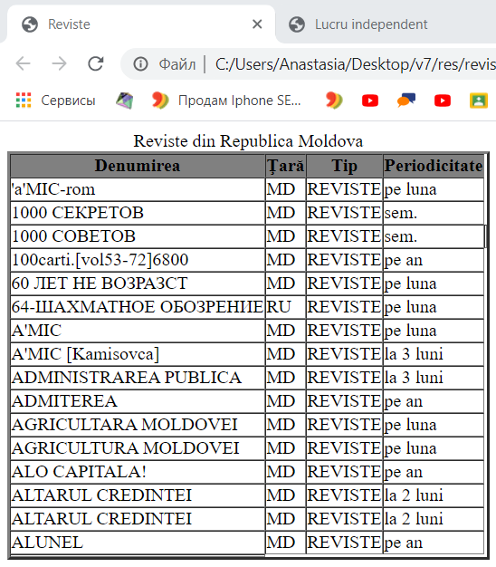

**Codul acestei pagini este:**

**<!DOCTYPE html>**

**<html>**

**<head >**

**<title>Reviste</title>**

**</head >**

**<body>**

**<table border="3" cellpadding="0" cellspacing="0">**

**<caption >Reviste din Republica Moldova**

**</caption>**

**<thead bgcolor="gray"><tr><th>Denumirea</th><th>Ţară</th><th>Tip</th><th>Periodicitate</th> </tr></thead>**

**<tbody>**

**<tr><td><div>'a'MIC-rom<div>**

**<div>**

**</div>**

**</div>**

**</div></td><td>MD</td><td>REVISTE</td><td>pe luna</td> </tr>**

**<tr><td><div>1000 СЕКРЕТОВ<div>**

**<div>**

**</div>**

**</div>**

**</div></td><td>MD</td><td>REVISTE</td><td>sem.</td> </tr>**

**<tr><td><div>1000 СОВЕТОВ<div>**

**<div>**

**</div>**

**</div>**

**</div></td><td>MD</td><td>REVISTE</td><td>sem.</td><td> </td></tr>**

**<tr><td><div>100carti.[vol53-72]6800<div>**

**<div>**

**</div>**

**</div>**

**</div></td><td>MD</td><td>REVISTE</td><td>pe an</td> </tr>**

**<tr><td><div>60 ЛЕТ НЕ ВОЗРАЗСТ<div>**

**<div>**

**</div>**

**</div>**

**</div></td><td>MD</td><td>REVISTE</td><td>pe luna</td> </tr>**

**<tr><td><div>64-ШАХМАТНОЕ ОБОЗРЕНИЕ<div>**

**<div>**

**</div>**

**</div>**

**</div></td><td>RU</td><td>REVISTE</td><td>pe luna</td> </tr>**

**<tr><td><div>A'MIC<div>**

**<div>**

**</div>**

**</div>**

**</div></td><td>MD</td><td>REVISTE</td><td>pe luna</td> </tr>**

**<tr><td><div>A'MIC [Kamisovca]<div>**

**<div>**

**</div>**

**</div>**

**</div></td>**

**<td>MD</td><td>REVISTE</td><td>la 3 luni</td> </tr>**

**<tr><td><div>ADMINISTRAREA PUBLICA<div>**

**<div>**

**</div>**

**</div>**

**</div></td><td>MD</td><td>REVISTE</td><td>la 3 luni</td> </tr>**

**<tr><td><div>ADMITEREA <div>**

**<div>**

**</div>**

**</div>**

**</div></td><td>MD</td><td>REVISTE</td><td>pe an</td> </tr>**

**<tr><td><div>AGRICULTARA MOLDOVEI<div>**

**<div>**

**</div>**

**</div>**

**</div></td><td>MD</td><td>REVISTE</td><td>pe luna</td> </tr>**

**<tr><td><div>AGRICULTURA MOLDOVEI<div>**

**<div>**

**</div>**

**</div>**

**</div></td><td>MD</td><td>REVISTE</td><td>pe luna</td></tr>**

**<tr><td><div>ALO CAPITALA!<div>**

**<div>**

**</div>**

**</div>**

**</div></td><td>MD</td><td>REVISTE</td><td>pe an</td></tr>**

**<tr><td><div>ALTARUL CREDINTEI<div>**

**<div>**

**</div>**

**</div>**

**</div></td><td>MD</td><td>REVISTE</td><td>la 2 luni</td> </tr>**

**<tr><td><div>ALTARUL CREDINTEI<div>**

**<div>**

**</div>**

**</div>**

**</div></td><td>MD</td><td>REVISTE</td><td>la 2 luni</td> </tr>**

**<tr><td><div>ALUNEL<div>**

**<div>**

**</div>**

**</div>**

**</div></td><td>MD</td><td>REVISTE</td><td>pe an</td> </tr>**

**<tr><td>**

**</td></tr></tbody>**

**</table>**

**</body>**

**<html>**

**Accesând saltarul ”canale TV” vedem:**

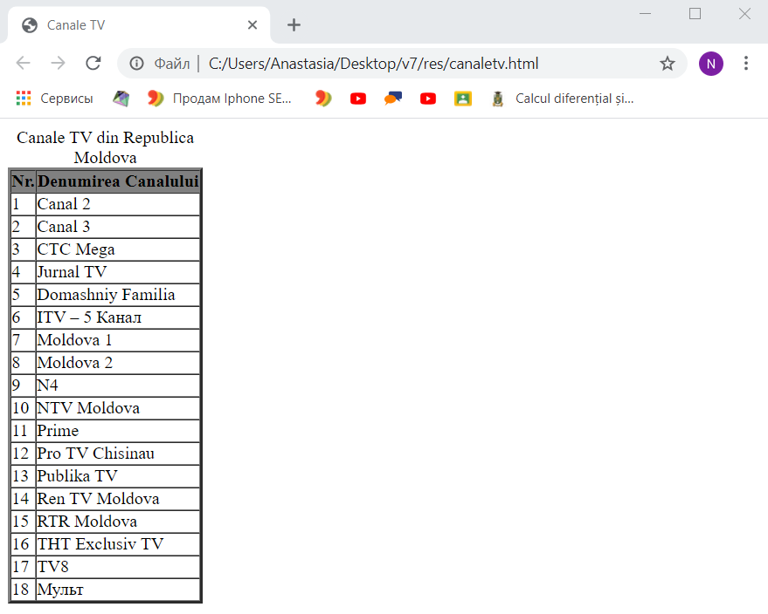

**Codul acestei pagini este:**

**<!DOCTYPE html>**

**<html>**

**<head >**

**<title>Canale TV</title>**

**</head >**

**<body>**

**<table border="3" cellpadding="0" cellspacing="0">**

**<caption >Canale TV din Republica Moldova**

**</caption>**

**<thead bgcolor="gray">**

**<tr>**

**<th>Nr.</th>**

**<th>Denumirea Canalului</th>**

**</tr>**

**</thead>**

**<tbody>**

**<tr>**

**<td>1</td>**

**<td>Canal 2</td>**

**</tr>**

**<tr>**

**<td>2</td>**

**<td>Canal 3</td>**

**</tr>**

**<tr>**

**<td>3</td>**

**<td>CTC Mega</td>**

**</tr>**

**<tr>**

**<td>4</td>**

**<td>Jurnal TV</td>**

**</tr>**

**<tr>**

**<td>5</td>**

**<td>Domashniy Familia</td>**

**</tr>**

**<tr>**

**<td>6</td>**

**<td>ITV – 5 Канал</td>**

**</tr>**

**<tr>**

**<td>7</td>**

**<td>Moldova 1</td>**

**</tr>**

**<tr>**

**<td>8</td>**

**<td>Moldova 2</td>**

**</tr>**

**<tr>**

**<td>9</td>**

**<td>N4</td>**

**</tr>**

**<tr>**

**<td>10</td>**

**<td>NTV Moldova</td>**

**</tr>**

**<tr>**

**<td>11</td>**

**<td>Prime</td>**

**</tr>**

**<tr>**

**<td>12</td>**

**<td>Pro TV Chisinau</td>**

**</tr>**

**<tr>**

**<td>13</td>**

**<td>Publika TV</td>**

**</tr>**

**<tr>**

**<td>14</td>**

**<td>Ren TV Moldova</td>**

**</tr>**

**<tr>**

**<td>15</td>**

**<td>RTR Moldova</td>**

**</tr>**

**<tr>**

**<td>16</td>**

**<td>ТНТ Exclusiv TV</td>**

**</tr>**

**<tr>**

**<td>17</td>**

**<td>ТV8</td>**

**</tr>**

**<tr>**

**<td>18</td>**

**<td>Мульт</td>**

**</tr>**

**</tbody>**

**</table>**

**</body>**

**<html>**